Lecture 5, September 7, 2010 (Key Points)

Towards a New Physical Approach to Understanding Statistical Power Laws in annual Flood Frequencies

      - We will use Poveda et al. (2007) for this lecture. Their work is based on two key ideas:

- How the mean annual streamflow is related to annual peak flow and low flow quantiles.

- Prediction of mean annual streamflow via water balance involving long-term hydro-climate variables, precipitation and evapotranspiration, respectively.

Relating Peak Flow Quantiles to Mean Hydro-Climatic Variables:

- Poveda et al. wrote,

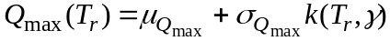 (5.1)

Here, 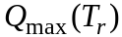 denotes the annual flood quantile corresponding to return period 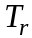, 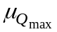and 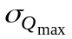are the mean and standard deviation of annual floods, and 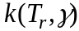 is a quantile of an assumed distribution of a random variable mean 0 and variance 1, and with probability of exceedance, 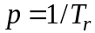.

- Poveda et al. assumed that is the quantile of a log-normal distribution, whose parameters are denoted by . This assumption is not quite correct. Why?
But it does not impact the rest of their results!

- Poveda et al. estimated mean streamflows and the mean and standard deviation of peak streamflows throughout Colombia, South America for the period 1966-1987 (22 years).

- They observed that power laws (scaling) relate and to mean streamflow, . The figure below shows the empirical power law relationships.

- Are the results in the figure based on the concept of a basin analysis or a regional analysis? Why?

- A new predictive equation for annual flood quantiles for any station in Columbia can be written by substituting power law relations from Fig. 1 into eq. (5.1). Replacing with using the water balance equation (Lecture 2), Eq. (5.1) can be written as,

(5.2)

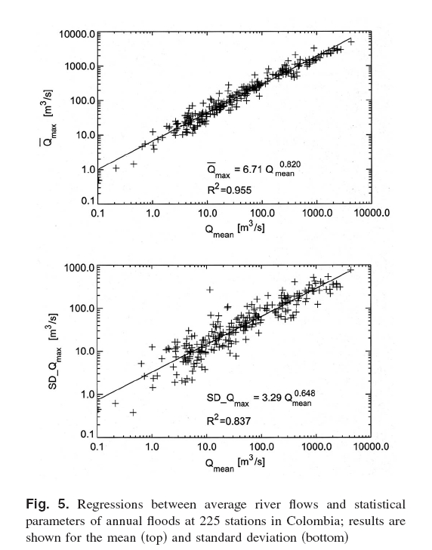

7. Eq. (5.2) predicts peak discharge for any basin throughout Colombia, even though Colombia is divided into 11 non-homogeneous climatic regions.

Power Laws in Low-Flow Quantiles

Power laws (scaling) relations between and to mean streamflow,
are given in Poveda et al. (2007) as shown below in Fig. 7.
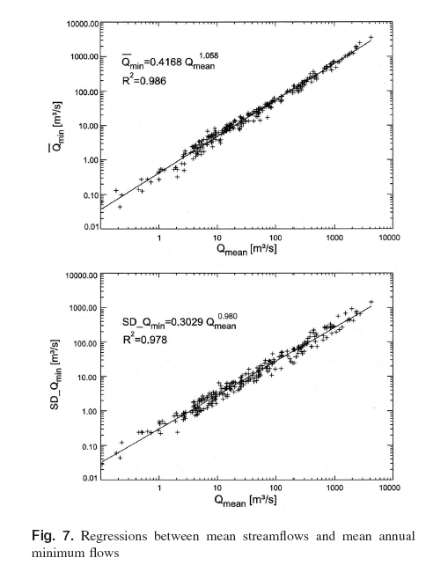

Long-term water balance
Poveda et al. computed mean annual flows using long-term water balance as , where A is drainage area, is mean precipitation and is mean evapotranspiration, and compared it with values of observed stream flows from 225 gauging stations covering Colombia (see Lecture 2 for various issues pertaining to the annual water balance).

- Precipitation data from 688 rain gauges with monthly records were used to estimate the average rainfall field over Colombia for the period 1966-1987. Kriging, a linear interpolation method related to least squares estimation was used to interpolate among gauges. (Kriging is not covered in the course).

Theoretical equations for estimating annual evapotranspiration
A multitude of theoretical expressions have been developed that can be used to compute estimates of annual . We will follow Poveda et al. (2007) to illustrate this

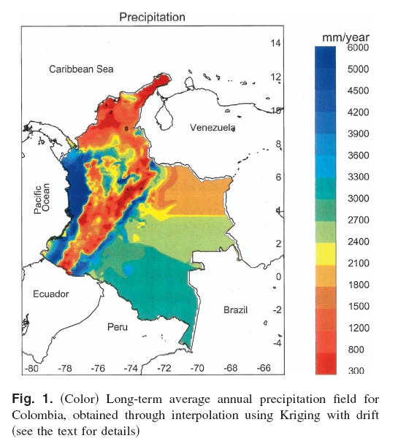
fundamental conceptual issue (Brutsaert, 2005 Ch. 4 covers evaporation). Fig. 2 gives estimates of ET from four different equations.
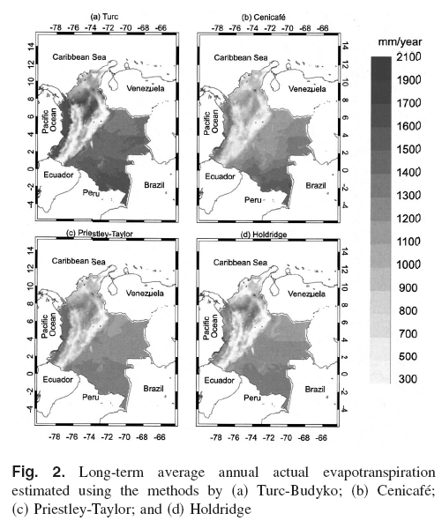
Poveda et al. (2007) used 9 equations to estimate . They used an estimate of and the water balance equation to calculate 9 different estimates for , and compared it with the estimates obtained from data. They computed the Root mean square (RMS) as a measure of how well the predicted mean runoff compares with the observed mean runoff using different models. The estimate from Turc’s equation gave the lowest RMS error shown in Fig. 3 below. For example, for Magdelena river basin (259,931 km²), the long-term river flow estimate is 8.034 m³/s, which can be compared with the measured long-term mean of 7,593 m³/s.
Turc’s equation gives an expression for annual as,

(5.3)
Here, is known as potential evapotranspiration (PET). It is the amount of water that can be evaporated and transpired if water availability is unlimited (for example in case of pan evaporation). Turc estimated PET through an empirical expression, , where is the mean annual temperature. Turc equation requires estimates of precipitation and temperature. Temperature fields (degrees C) were estimated from regional linear relationships observed in data for 1002 temperature

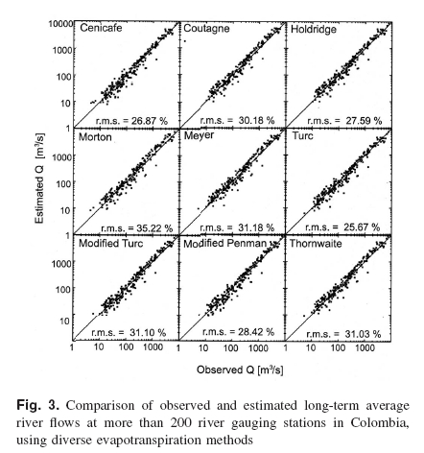

stations. For example, the expression for the Andean region is, T = 29.42 – 0.0061h ; h is elevation in meters.

Important Questions

- Can the empirical USGS regional regression equations be used to obtain relations similar to eq. (5.2)?

- What is the physical basis of power law relations for the mean and standard deviation of annual floods and low flows with respect to long-term mean runoff in Figure 5 and Figure 7?

- How can the parameters in the power laws () be understood in terms of hydrologic processes governing precipitation, evapotranspiration, storages, infiltration, and stream flows?

- Questions 2 and 3 bring us to the current state of hydrologic science and engineering. It is an important topic for current and future research.

References:
1. Poveda et al. J. Hydrologic Eng. (ASCE), January/February, 4-13, 2007.

